EXCEL SALES ANALYTICS MINI PROJECT
Project Documentation — Sessions S01–S10
1. Project Overview
The Excel Sales Analytics Mini Project uses Microsoft Excel to analyze sales performance across regions, products, months, salespeople, customer types, and sales channels.
Objective: To clean and organize sales data, analyze business performance, create an interactive dashboard, perform What-If Analysis, and identify useful business insights.
Business Problem: Sales information needs to be organized and summarized so that management can understand revenue performance, identify successful products and regions, and make better business decisions.
2. Workbook Structure
The 2 workbooks contains the following sheets:
1. Main Project Worksheets
- Customers
- Employees
- Products
- Cleaned Sales
- What-If Analysis
- Dashboard
2. Template Worksheets
- Start Here
- Formula Practice
- Pivot Analysis
- Business Insights
- PowerQuery Log
- Data Dictionary
- What – IF analysis
Tools used: Microsoft Excel, Power Query, Excel Tables, formulas, PivotTables, PivotCharts, slicers, Timeline, Scenario Manager, Goal Seek, and Sparklines.
3. Data Cleaning and Power Query
Power Query was used to combine monthly sales CSV files and merge the Product_Master, Customer_Master, and Employee_Master data using matching ID fields.
The final dataset was loaded into an Excel Table named Sales_Clean.
The main data-cleaning activities included:
- Removing duplicate records.
- Trimming extra spaces.
- Standardizing text formatting.
- Correcting an incorrect date.
- Handling missing customer and product information.
- Creating an Order_Band helper column based on revenue ranges.
- Preparing a Data_Dictionary sheet to explain the dataset fields.
The Refresh All test was marked YES in the PowerQuery_Log sheet.
These steps helped organize the sales data for analysis.
4. PivotTables and Sales Analysis
PivotTables were created to summarize sales data from different business perspectives.
The main analyses included:
- Revenue by region.
- Revenue by product and Top 5 products.
- Monthly revenue trends.
- Revenue by category.
- Salesperson performance.
- Revenue as a percentage of Grand Total.
- Monthly revenue compared with targets.
- Average revenue and quantity analysis.
- Customer and order counts.
- Order counts by revenue band.
The Sum, Count, and Average value settings were used where appropriate. Monthly dates were grouped to analyze sales trends over time.
These PivotTables helped identify high-performing regions, products, categories, salespeople, and customer groups.
5. Interactive Dashboard
An interactive Excel dashboard was created to present the main sales results on one screen.
5.1 KPI Cards
The dashboard contains six KPI cards:
- Total Revenue
- Total Orders
- Total Units Sold
- Average Order Value
- Top Region
- Top Product
The total revenue is approximately ₹2.27 crore (₹22,719,903.09).
5.2 Charts
Seven charts were created:
- Revenue by Region
- Monthly Revenue Trend
- Revenue by Category
- Top 5 Products
- Salesperson Performance
- Revenue by Category Type
- Order Distribution by bands
5.3 Interactive Features
The dashboard includes:
- Region slicer.
- Category/Product slicer.
- Salesperson slicer.
- Product Slicer.
- Order Date Timeline.
- Report Connections for compatible PivotTables.
These features allow users to filter the dashboard and explore sales performance from different perspectives.
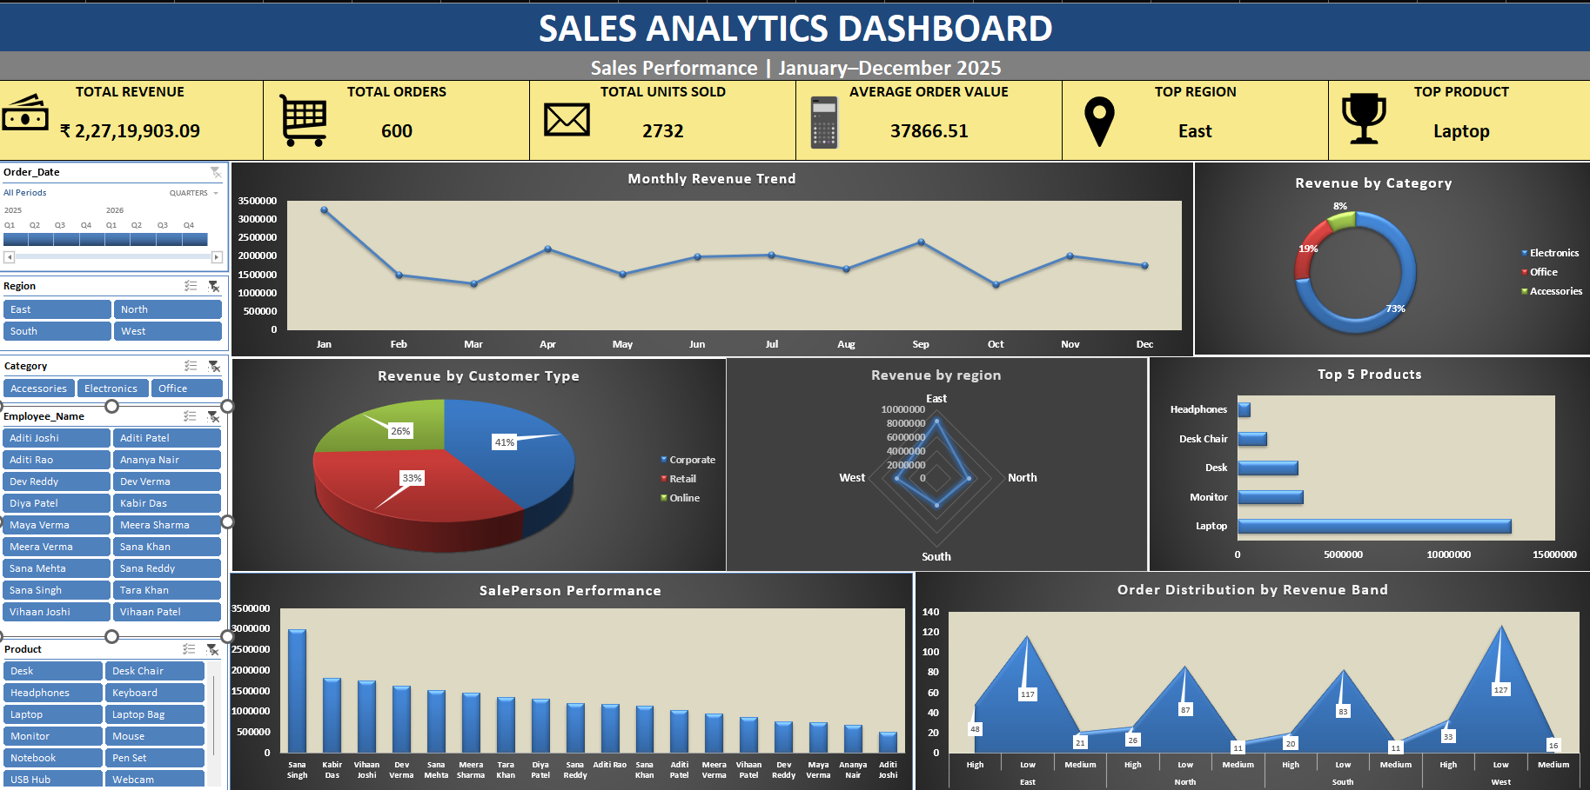

6. What-If Analysis
What-If Analysis was performed to understand how revenue changes under different assumptions. Scenario Manager was used to compare scenarios, and Goal Seek was used to determine the growth required to reach a target.
Scenario | Assumption | Projected Revenue
Base Case | 0% | ₹22,719,903.09
Conservative | -5% | ₹21,583,907.94
Growth | +10% | ₹24,991,893.40
Aggressive | +20% | ₹27,263,883.71
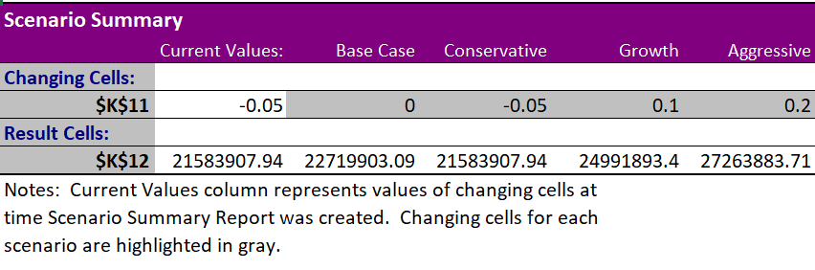
Goal Seek
The target revenue was ₹30,000,000 (₹3 crore).
Goal Seek calculated that approximately 32.04% growth would be required to reach the target.
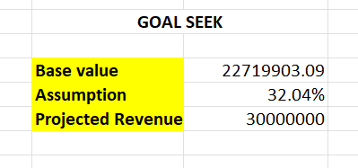
A monthly revenue Sparkline was also created to display the monthly revenue pattern in a compact visual format.
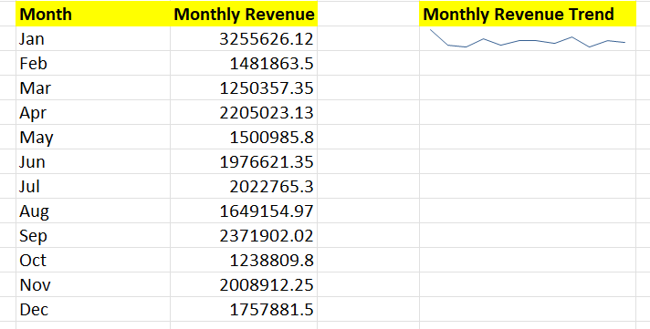
This analysis helps compare possible outcomes and supports revenue planning.

7. Business Findings and Recommended Actions
Finding 1: Highest-Revenue Region
Evidence: East has the highest revenue when no filters are applied.
Recommended action: Maintain the region's strengths and investigate growth opportunities in other regions.
Finding 2: Strongest Product
Evidence: Laptop is the top product in the Top 5 Products PivotTable.
Recommended action: Monitor stock levels and continue promoting this product.
Finding 3: Monthly Revenue Performance
Evidence: January has the highest revenue, while October has the lowest.
Recommended action: Review the factors that contributed to January's performance and investigate the decline in October.
Finding 4: Highest Average Revenue Category
Evidence: Electronics has the highest average revenue at approximately ₹78,772.02.
Recommended action: Maintain sufficient stock of Electronics products and explore ways to improve sales in other categories.
Finding 5: Salesperson Performance
Evidence: Sana Singh has the highest sales revenue.
Recommended action: Share effective sales practices with the team.
Finding 6: Customer Type Performance
Evidence: Corporate customers contribute the highest revenue.
Recommended action: Strengthen relationships with corporate customers and encourage repeat purchases.
Finding 7: Sales Channel Performance
Evidence: Phone is the best-performing sales channel.
Recommended action: Maintain good phone-sales support and customer service.
Finding 8: Contribution of Top Five Products
Evidence: The top five products generate ₹20,848,399.25, approximately 91.76% of total revenue.
Recommended action: Maintain the availability of these products while promoting other products to diversify revenue.
Finding 9: Revenue Scenarios
Evidence: Projected revenue is ₹21,583,907.94 under the -5% scenario, ₹24,991,893.40 under the +10% scenario, and ₹27,263,883.71 under the +20% scenario.
Recommended action: Use these scenarios to plan conservative, expected-growth, and aggressive revenue targets.
Finding 10: Data Quality
Evidence: Data preparation included removing duplicates, trimming spaces, standardizing text, correcting an incorrect date, handling missing customer and product information.
Recommended action: Apply data validation and conduct regular data-quality checks to improve accuracy.

8. One-Page Business Summary
The Excel Sales Analytics Mini Project was developed to organize sales information and analyze business performance using Microsoft Excel.
Power Query was used to combine monthly sales files and enrich the transaction data with product, customer, and employee information. Data cleaning addressed duplicates, extra spaces, text inconsistencies, an incorrect date, missing customer and product information, and a product-category correction.
PivotTables and PivotCharts were used to analyze revenue by region, product, category, month, salesperson, and customer type. An interactive dashboard was developed with six KPI cards, seven charts, slicers, and a date Timeline.
The total revenue was approximately ₹2.27 crore. East was the leading region, Laptop was the top product, January had the highest monthly revenue, and October had the lowest. Electronics had the highest average revenue at approximately ₹78,772.02. Corporate customers contributed the highest revenue by customer type, and Phone was the best-performing sales channel.
The top five products generated approximately 91.76% of total revenue. What-If Analysis showed the possible impact of revenue changes under -5%, +10%, and +20% scenarios. Goal Seek indicated that approximately 32.04% growth would be required to reach ₹3 crore.
The findings suggest maintaining leading-product availability, strengthening corporate customer relationships, improving weaker sales periods and regions, and diversifying revenue across more products. Regular data-quality checks are also recommended.
Overall, the project demonstrates how Excel can transform sales data into meaningful summaries and practical business recommendations.
9. Session Status
- S01–S02: Completed as instructor-assigned formula practice tasks, separate from the main project.
- S03–S05: Continued learning and practice tasks; not included as completed main-project deliverables.
- S06–S07: PivotTables, PivotCharts, dashboard, slicers, Timeline, and Report Connections completed.
- S08: Power Query preparation completed; Refresh All test marked YES.
- S09: Dashboard KPIs, Sparkline, Scenario Manager, and Goal Seek completed.
- S10: Business Insights and project analysis completed; the business summary is included in this documentation.
10. Conclusion
The Excel Sales Analytics Mini Project demonstrates how data cleaning, Power Query, PivotTables, PivotCharts, dashboard interactivity, and What-If Analysis can be used to understand sales performance.
The analysis identified leading regions, products, customer groups, salespeople, and channels. Scenario analysis also helped evaluate possible revenue outcomes and estimate the growth required to achieve the target.
Regular data-quality checks and review of the known Top Product KPI limitation will help improve the reliability of the workbook. Overall, the project provides a practical example of using Excel for sales analysis and business decision-making.

